Axioms of Probability

Non-Negative Axiom
- For an event A, P(A) ≥ 0
  - Probability can never be negative

Normalization Axiom
- P(S) = 1
  - The probability that something in the sample space happens is 1

Additivity Axiom (disjoint events)
- If A and B are mutually exclusive (i.e., A ∩ B = ∅), then

P(A∪B) = P(A) + P(B)

More generally, for any countable collection of disjoint events:

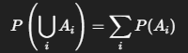

Using the above, we can derive:

